Document Presentation - Advanced
Document Presentation - Advanced

CONTENTS

- CHARACTER LIST

  - MATHEMATICAL SYMBOLS
  - SPECIAL CHARACTERS
  - ACCENTS
  - MEASURES

- CHARACTER ATTRIBUTES

  - MATHEMATICAL SYMBOLS
  - SPECIAL CHARACTERS
  - ACCENTS
  - MEASURES

SUBSCRIPT/SUPERSCRIPT
  - BULLETS

- DRAWING ATTRIBUTES

  - TEXT BOXES
  - TEXT BOX SIZES
  - SHADING
  - PAGE BORDERS
  - DIVIDERS

- WRAPPING STYLES

  - SQUARE
  - TIGHT
  - IN FRONT OF TEXT
  - BEHIND TEXT

- PAGE LAYOUTS

- LINE LENGTH
- COLUMNS

- GRAPHICS

- CLIP ART PREPARATION

Document Presentation - Advanced
1. CHARACTER LIST

MATHEMATICAL SYMBOLS

± | = | Ctrl | & | 1
≥ | = | Ctrl | & | 2
< | = | Ctrl | & | 3
> | = | Ctrl | & | 4
≈ | = | Ctrl | & | 5
π | = | Ctrl | & | 6
∞ | = | Ctrl | & | 7
ƒ | = | Ctrl | & | 8
∫ | = | Ctrl | & | 9
√ | = | Ctrl | & | 10
≠ | = | Ctrl | & | 11
∑ | = | Ctrl | & | 12
ϑ | = | Ctrl | & | 13
ς | = | Ctrl | & | 14
ϕ | = | Ctrl | & | 15
α | = | Ctrl | & | 16
ψ | = | Ctrl | & | 17

SPECIAL CHARACTERS

™ | = | Ctrl | & | 18
© | = | Ctrl | & | 19
® | = | Ctrl | & | 20

ACCENTS

è | = | Ctrl | & | 21
é | = | Ctrl | & | 22

MEASURES

¼ | = | 1/4 & Space Bar
½ | = | 1/2 & Space Bar
¾ | = | 3/4 & Space Bar

Document Presentation - Advanced
2. CHARACTER ATTRIBUTES

MATHEMATICAL SYMBOLS

- Click “Insert” on the “Menu Bar.”
- Click “Symbol.”
- Within the “Symbol Dialog Box” click the “Symbol Font” within the “Font Option.”
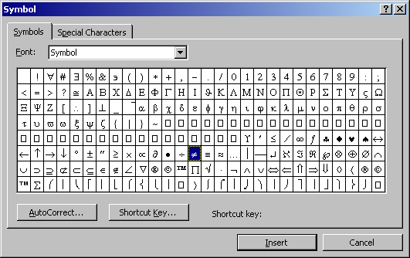 It is now possible to assign a “Keyboard Shortcut Key” for each symbol.
- Click the symbol required.
- Click the “Shortcut Key Tab.”
- Press the “Ctrl Key” and a “Numeric Key.”
- Click the “Assign Tab.”
- Click “CLOSE.”
- Click “CLOSE.” again.
It is now possible to press the “Ctrl Key” and designated “Numeric Key” for the required
symbol.

MATHEMATICAL SYMBOLS
(Symbol Text Option) ± ≥ < > ≈ π ∞ ƒ ∫ √ ≠ Σ ϑ ς ϕ α ψ

SPECIAL CHARACTERS

(Symbol Text Option) ™ © ®

ACCENTS
(Normal Text Option) è é

MEASURES (KEYBOARD ENTERED)

1/4 | & | Spacebar | = | ¼
1/2 | & | Spacebar | = | ½
3/4 | & | Spacebar | = | ¾

SUBSCRIPT/SUPERSCRIPT

- 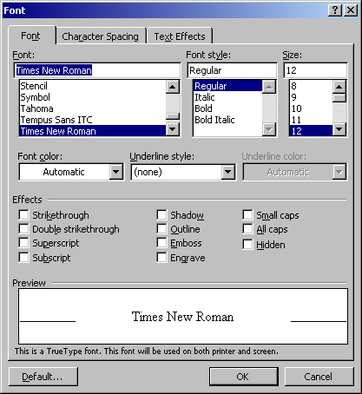 Highlight character.
- Click the “Right Handle” of the “Mouse.”
- Click “Font.”
4. Within the “Font Dialog Box” click _{“Subscript”} or “^{Superscript.”}
5. Click “OK.”

BULLETS

- Highlight text.
- Click the “Right Handle” of the “Mouse.”
3. Click “Bullets and Numbering.”
- Within the “Bullets and Numbering Dialog Box” click the “Bulleted Tab.”
- Click the desired bullet.
- Click “OK.”

Document Presentation - Advanced
3. DRAWING ATTRIBUTES

TEXT BOXES

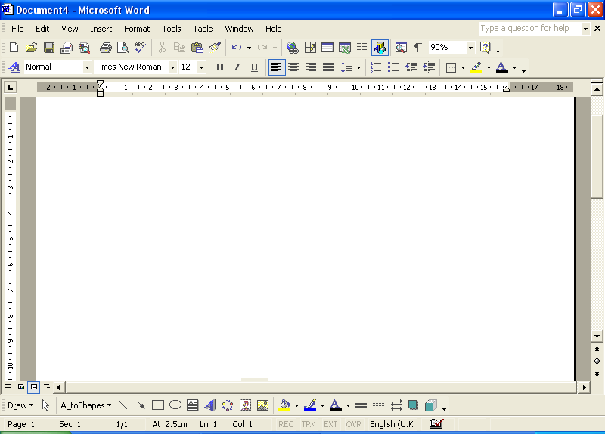1. Highlight text.
2. Click the “Text Box Button” on the
“Drawing Toolbar.”

It is now possible to use the following
functions as required for this examination.

TEXT BOX SIZES

- Click on the “Text Box Perimeter.”
- Click the “Right Handle” of the “Mouse.”
- 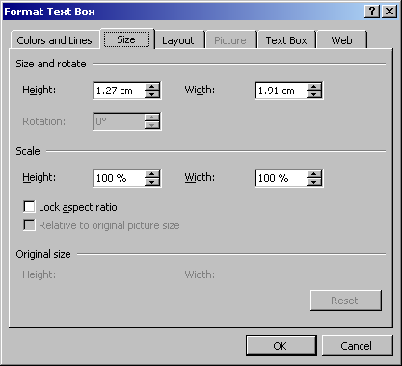 Click “Format Text Box.”
- Within the “Format Text Box Dialog Box” click the “Size Tab.”
- Tab down to the “Height Adjuster” within the “Size and Rotate Option.”
- Highlight the showing measure.
- Type in the required height.
- Tab across to the “Width Adjuster.”
- Type in the required width.
- Click “OK.”
SHADING

- Click on the “Text Box Perimeter.”
- Click the “Right Handle” of the “Mouse.”
- Click “Format Text Box.”
- Within the “Format Text Box Dialog Box” click the “Colors and Lines Tab.”
- Click the “Color Option” within the “Fill Option.”
- Click the “More Colors Option.”
- Click the “Standard Tab” within the “Colors Dialog Box.”
- Click a suitable shade from the “Colors Option.”
- Click “OK”
- Click “OK” again.
PAGE BORDERS

- Highlight page text.
- Click the “Text Box Button” on the “Drawing Toolbar.”
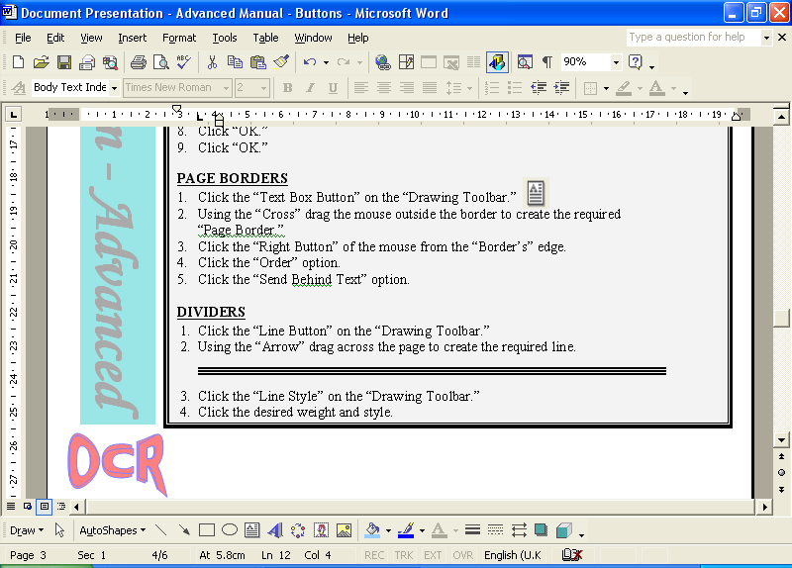 DIVIDERS

- Click the “Line Button” on the “Drawing Toolbar.”
- Using the “Cross” drag the “Mouse” outside the “Drawing Canvas” to create any of the
following lines:

1pt

3pt

Document Presentation - Advanced
4. WRAPPING STYLES

CLASSES TO RACE

SQUARE

If there are 5 or more entries in any class for which a separate race has not been organised, then they will start with the most suitable handicap class and will be treated as a separate class for results and prizes.

If a yacht does not have such a number, the committee will use the formulae (D ÷ 2240) ÷ (0.01 x L)³ and S ÷ (D ÷ 64)^{2/3} to compare the performance if different yachts, where D is displacement, L is load waterline and S is sail area.

CONDITIONS OF ENTRY

The race organisers shall not be liable for any loss, damage, death or personal injury howsoever caused to the owner and crew, as a result of their taking part in the race or races. Moreover every owner warrants the suitability of his yacht for the race or races, and the suitability and adequacy of his insurance cover.

TIGHT

Safety equipment must be properly maintained, stowed and in date and the competition must know where it is kept and how to use it.

RACE ENTRY FORM AND FEES

IN FRONT OF TEXT
Entries to race shall be by the completion of the regatta race entry form, the payment of the appropriate fee and their acceptance by the race organising committee. A separate entry form must be submitted for each yacht.

POSTPONED OR ABANDONED RACES

Races postponed will not be re-scheduled, neither will race fees be refunded.

SAILING INSTRUCTIONS

BEHIND TEXT
Race instructions will be issued from the committee room from 1200 hours on Friday 1 August onwards. Courses will also be displayed on a board outside the yacht club at least 2 hours outlined below will be used.

Document Presentation - Advanced
5. PAGE LAYOUTS
IN
LINE LENGTH

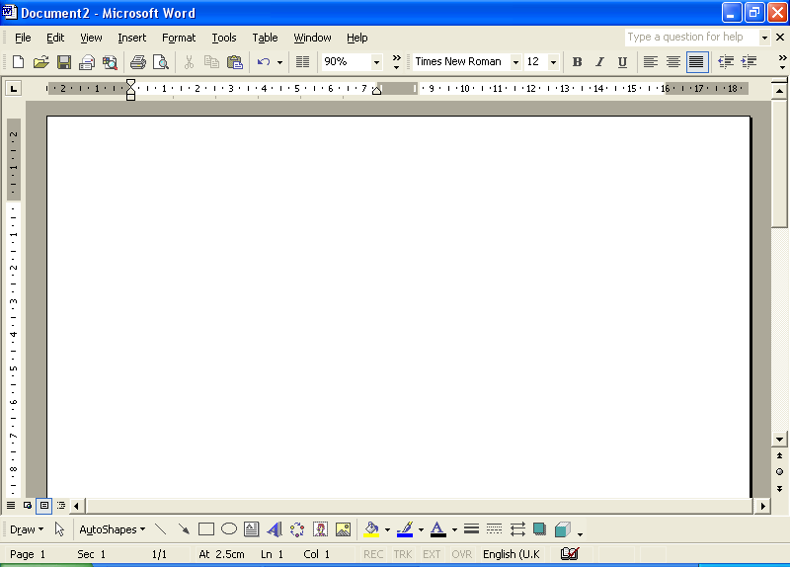
- Press the “Ctrl and A Key” simultaneously to select all text.
- Click the “Full Justification Button” on the “Formatting Toolbar.”
- Position the “Mouse’s Pointer,” “Ruler Marker” to the “Left Margin’s” “Double Sided
Arrow’s Display.”
- Drag the “Margin Counter” to the required “Line Length.”
- Repeat this for the “Right Margin.”
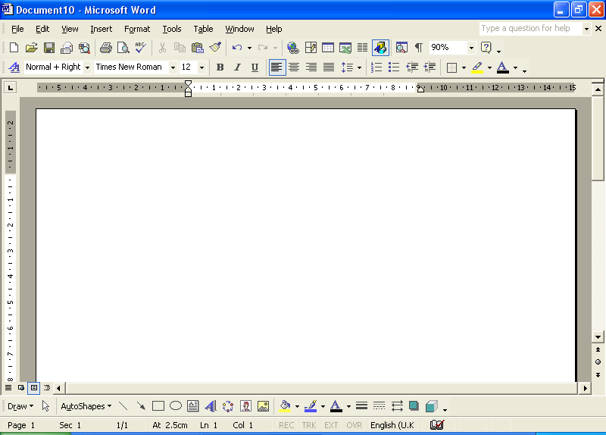

LINE LENGTH

Line  Length |  | L/R  Margins
9 | = | 6.0 cm
10 | = | 5.5 cm
11 | = | 5.0 cm
12 | = | 4.5 cm
13 | = | 4.0 cm
14 | = | 3.5 cm
15 | = | 3.0 cm
16 | = | 2.5 cm

COLUMNS

- 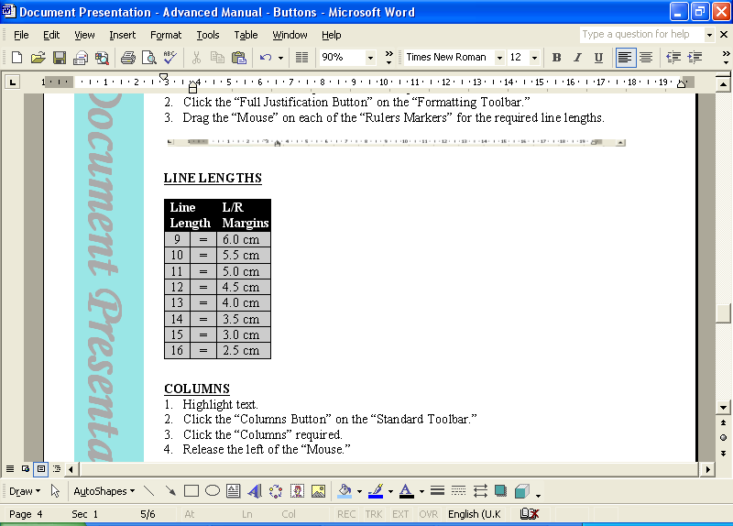 Highlight text.
- Click the “Columns Button” on the “Standard Toolbar.”
- Click and drag the “Left Handle” of the “Mouse” for the required columns.
- Release the “Handle.”

We would like to thank you for such an enjoyable holiday. Jeremy worked us hard, but he gave us the confidence to put into practice what we had learnt in the security of the theory sessions.

What a star! I cannot remember when I have enjoyed myself so much. Jeremy is an excellent instructor and is as much an asset as your comfortable yachts and up-to-date equipment.

Now I have to return to real life and my not very well equipped boat and far from scenic sailing areas.

The holiday was over far too quickly and I shall have to come back next year. I hope the weather will be as perfect and the food and wine as delightful.

Although we have sailed all our lives, we feel far more competent to approach moorings under sail, tie up to floating pontoons and harbour walls. Our clients say it for us.

Document Presentation - Advanced
6. GRAPHICS

CLIP ART PREPARATION
    - 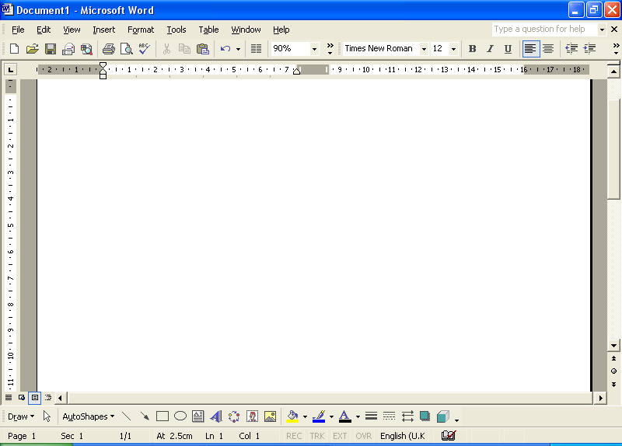 Position the cursor to the required insertion point.
- Click the “Insert Clip Art Button” on the “Drawing Toolbar.”
3. Type in a suitable name for a graphic of preference within the
“Search Text Option.”
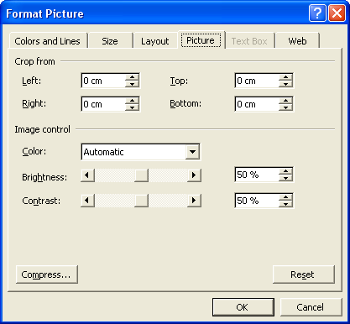4. Click the “Search Tab.”
    - Click a suitable graphic to insert.
    - Click the “X” to close.
    - Click the “Right Handle” of the “Mouse.”
    - Click “Format Picture.”
    - Within the “Format Picture Dialog Box” click the “Layout Tab.”
10. Click the “Square Option” within the “Wrapping Style Option.”
11. Click “OK.”

It is now possible to align the graphic as specified.
We would like to thank you for such an enjoyable holiday. Jeremy worked us hard, but he gave us the confidence to put into practice what we had learnt in the security of the theory sessions.

What a star! I cannot remember when I have enjoyed myself so much. Jeremy is an excellent instructor and is as much an asset as your comfortable yachts and up-to-date equipment. Now I have to return to real life and my not very well equipped boat and far from scenic sailing areas.

The holiday was over far too quickly and I shall have to come back next year.

I hope the weather will be as perfect and the food and wine as delightful.

Although we have sailed all our lives, we feel far more competent to approach moorings under sail, tie up to floating pontoons and harbour walls.

